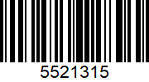
Covid19 hon test antigen: mat+
prelev+analys+rapport (€26,72)

Covid19 hon test antigen: mat+
prelev+analys+rapport (€26,72)

Covid19 hon test antigen: mat+
prelev+analys+rapport (€26,72)

Covid19 hon test antigen: mat+
prelev+analys+rapport (€26,72)

Covid19 hon test antigen: mat+
prelev+analys+rapport (€26,72)

